Kasim Sulton Magazine
Tuesday 12th August 2003 - #4

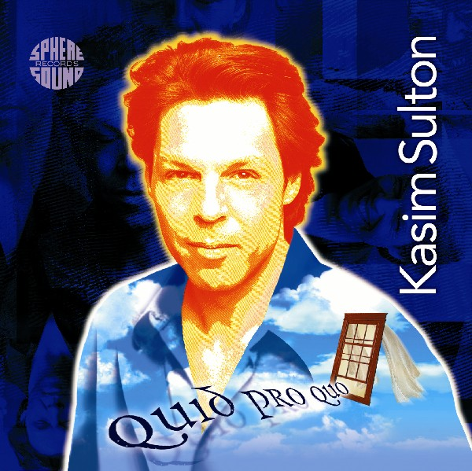  Kasim’s latest CD Quid Pro Quo is available via the Sphere Sound Records website at http://www.SphereSound.com  ----------------------------  On Stage  Kasim’s concerts (both with Meat Loaf) for the next 2 weeks are:  Saturday 23rd – Meadowbrook Farm, Gilford, NH  Monday 25th – Great New York State Fair, Syracuse, NY  Unfortunately the only concert that Kasim could possibly open is the one in Gilford, NH.  http://www.KasimInfo.com/2003 has links to venues and ticketing. Tickets are still available for both the concerts.   | Welcome to the Kasim Sulton Magazine (by KasimInfo.com). The magazine is issued every other week to all members of the Yahoo Kasim Sulton mailing list.  The idea of the magazine is that it will be a fully printable (and therefore permanent) record containing news, photos, reviews, articles, interviews and so on. If you would like to contribute anything to future copies please send them to SueW@KasimInfo.com  ----------------------------  Index  Latest News………………………...1  Editorial / Intro….…………..……2  Remember………………………..….3  Oh No! …………………………………6  Photos…………………………..….... 7  Kasim – A Life of Travel ………. 9  All The Right Reasons .…..…….13  Over For Now………………..…….14  Stop Press!  There will be an online chat with Kasim at 6.00pm on Saturday 16th in the Yahoo chatroom!  All items are correct at the time of release. Please note that due to the nature of the business all appearances are liable to change or cancellation at short notice.  Please send any submissions, comments and views to SueW@KasimInfo.com.  KasimInfo.com is not an official site but all items are confirmed as far as possible.  Kasim Sulton’s official website is KasimSulton.com.
Editorial / Intro

What a disappointing two weeks these have turned out to be with two concerts cancelled in California and now their appearance on Good Morning America also cancelled. Unfortunately too the Lancaster and Anaheim concerts were ones that Kasim was expected to open!

Of the concerts that they did play in these past two weeks, there were mixed opinions from both fans and the critics – in fact the only thing that everybody seems to have agreed on is about how well the musicians in the band are playing together!

On the plus side, Kasim updated his official website with a new message and has made a couple of posts to the messageboard arranging a chat for this Saturday (not Sunday as usual) at 6.00pm in the usual Yahoo chatroom.

Kasim also met up with Willie Wilcox when he was in Mexico last weekend and the photo of their meeting was posted on both KasimSulton.com and KasimInfo.com. Some additional photos of Kasim that evening were added to KI.com which certainly raised a few temperatures amongst the female population!

As we all know on the Internet things get posted quickly and someone’s opinion becomes a rumor which soon becomes a “fact”. As KasimInfo.com is often updated frequently, I was taken in by one of these hoaxes a couple of days ago. Someone posted on a messageboard that the second Mexico concert had been cancelled “but not due to Meat Loaf’s voice” (it later transpired that the venue had just been changed). I posted a comment on KI.com to that effect but 4 minutes later a retraction was posted on the original site so I made a very quick edit on my Blog – hopefully nobody saw it!

About a day or so later the same guy posted that “the bass player” was ill and that his place was to be taken at the Mexico concerts by Nicky Sixx of Motley Crue! This time my suspicions were aroused so I checked and the rumor was totally false. I’m still puzzling out how they thought that Sixx would learn all the bass parts for the concert and get down to Mexico all in such a short space of time anyway!

As you all know when I sent KSM#3 I discovered that Yahoo has a 1MB limit on e-mails. Hopefully uploading the magazine to the files section of Yahoo will solve this problem and you can all download it at your leisure (within the 2 week timeframe) but if you would like to receive the magazine directly into your in-box, please e-mail SueW@KasimInfo.com and I will add you to the list. All names are mailed as bcc’s.

The essay in this edition is longer than normal (as is the old interview) so rather than bombard you with even more words, I’ve added a section called “Oh No!” taken from some of Kasim’s posts on the messageboards.

Enjoy ……!

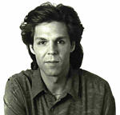
Remember…..

This is the section of the magazine which recalls interviews or reviews from earlier days.
This was an article that was published in the Arts and Entertainment section of The New London Day (in the Westerly, RI area) on 1st February 2002.
Many thanks to Rick Koster, Lance Johnson, The Day Publishing Company and David Killary for helping and giving permission for this article to be reproduced.

The Sideman At The Hidden Heart of Hits
by Rick Koster
Day Arts Writer
Every 15 years of so, musician Kasim Sulton gets around to feeding his own muse. There was that solo album in 1982, "Kasim," and now, in a completely different millennium, he's releasing a new CD, "Quid Pro Quo."
It's a question of time, not talent.
Sulton, you see, has for almost three decades been a highly coveted sideman to a Milky Way of rock and pop stars. He played bass on Meat Loaf's "Bat Out of Hell" and has led the Loafster's touring band for years. He's done sessions for Celine Dion, Mick Jagger, Bon Jovi, and Cheap Trick - to name a few of dozens. He's toured with such stylistically diverse artists as Joan Jett and Hall & Oates.
And perhaps most notably, Sulton, an original member of Todd Rundgren's progressive pop experiment, Utopia, remains one of Rundgren's principal musical confidantes.
As for his own talents, Sulton is an accomplished songwriter, producer, bassist, guitar player, keyboardist, and has the voice of a happy angel - all of which are on high-beam display with "Quid Pro Quo." The CD will be out any day and is the reason for a one-man acoustic tour that brings him to Carley's in Westerly at 9p.m. Saturday.
An advance sampling of "Quid Pro Quo" reveals a batch of pristine, sophisticated pop songs. "Before She Was Gone" is an exemplary ballad that, in a just world, would dominate adult alternative radio. "Heaven Help the Child" is a lullaby one would expect from the father of three daughters - which Sulton is - and "Over For Now" is a refreshing bit of post-alt-rock, one-man doo-wop.

"Wow, it's been a long time since I put this much energy into my own stuff," says Sulton, 46, referring to "Kasim," an album released at the height of Utopia's popularity that made less than a huge splash. "For most of my career, I've been a passenger in someone else's car. We're always going interesting places, and the view is spectacular, but with this particular car I'm driving."
In a sense, suggesting that Sulton has been riding shotgun all these years is misleading. He's been working on his own material over that time, but the process is obviously slower given his schedule. Sulton played all the instruments and did all the vocals on "Quid Pro Quo," which further protracted the experience.
"I am doing the entire CD by myself," Sulton says. "It takes forever that way, but I can do it right. And it's been so long since I've had a record out that it doesn't matter if it takes a bit longer."
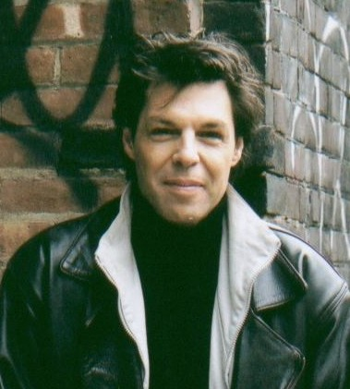

Not that Sulton suffers from anonymity. He joined Utopia as a teenager in 1977 and the band released nine albums through the 1986, including classics like "Ra," "Utopia," "Oops! Wrong Planet" and "Swing To The Right." Sulton wrote the band's only Top 30 hit, "Set Me Free," from "Adventures in Utopia."
In a prog market dominated by British and European bands, Utopia was a frequently incredible and visionary band, one that Sulton wouldn't mind seeing resurrected. After all, he was onboard in 2000 for Rundgren's enthusiastically received "Power Trio" tour, which dipped into Todd's expansive past and performed two summers ago at the Mohegan Sun Wolf Den.
"I talk to Todd about reuniting Utopia," Sulton says. "I say, 'What's the big deal? Styx and Bad Company go out and have a good time.' Todd's like, 'Ah, I don't wanna do that.'
"But I'm trying to beat him down. You know: 'Would you just shut up and let's do it already?'"
For now, Sulton is happy to have some new product in the marketplace, and to have the opportunity to hop in his car, relax with some talk radio, and cruise the highways to play for folks.
"I'm a musician and a songwriter. That's what I do," Sulton says. "In my line of work, there's no insurance, no stock options, no corporate buyouts or golden parachutes. This is the second time I've gone solo in 20 years, so I'm hoping there'll be a natural progression."
Like many rockers who experienced a modicum of success at an early age, Sulton admits he lacked the discipline to handle it responsibly.
"I'm much more seasoned and wise now. At this point," he laughs, "I just wanna be Jimmy Buffet."
Sulton on his memorable gigs:
Todd Rundgren: "I don't care what Todd does or wants to do musically - it's always challenging and I always enjoy it. My relationship with him over the years has gotten so good that there's an unspoken intuition there. As far as working on his solo stuff is concerned, I will say that, if he wants your opinion, he'll ask for it."
Meat Loaf: "It's challenging in different ways than playing with Todd. It's a specialty act - hard-driving, very big music. It's fun being out there, but it's three hours of hard work every night. He gets my wife and daughters Christmas presents."
Celine Dion: "In the studio, she doesn't do more than one take. That's it. And she has to have - she requires - lighted candles when she sings. I don't mean a dozen candles. I mean a couple hundred."
Joan Jett: "It was fun playing with Joan but, at my age, I don't have the energy to do something I don't really enjoy. I did my 'Sting' thing with her for three years" - referring to the era when Sting hired the cream of the jazz world to tour as his backing band - "and that's enough. I appreciate and respect her but the music isn't my cup of tea."
Hall & Oates: "They're great performers and we had a great band. I could look forward to getting onstage every night knowing I was gonna have a good time."
Please note that this article has been reproduced as printed (Kasim has two daughters and one son!)
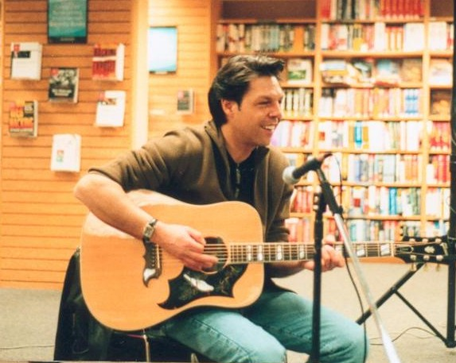
Oh No!
Ever one to keep our interest on the messageboards, Kasim Sulton has run a few quizzes for Kasim-goodies over the past few months.

Here’s a selection of some of the questions. Test your knowledge to see how many answers you get correct .…. the second time around!

- Who says the spoken “Quid Pro Quo” on the beginning of the album?
- While on the road with Todd Rundgren during the Power Trio Tour, Kasim fell on stage, breaking his foot. At which show (City and State) did this happen?
- In which month of 1976 did Kasim officially join the band Utopia?
- What was the song Kasim sang Lead Vocals on while Ringo Starr played drums during the Jerry Lewis Muscular Dystrophy Telethon?
- Exactly how many SOLO shows have Kasim performed since April 2001 up to and including November 2002? Remember... SOLO SHOWS ONLY
- What was the highest Billboard Singles chart position that 'Set Me Free' achieved?
- Which months and year did Kasim perform in the band Cheap Trick?
- What was the drink Paul McCartney asked Kasim to get for him at the Knebworth Festival in England?

(Answers on page 13.)

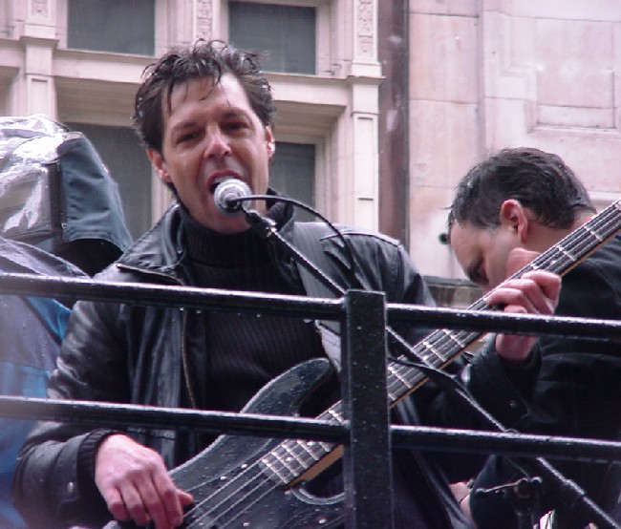
Photos!

All the photos in this section this week are by Frank Ciapanna

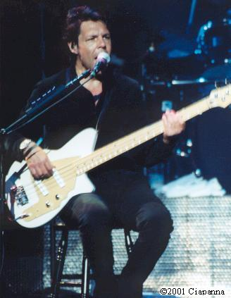 | 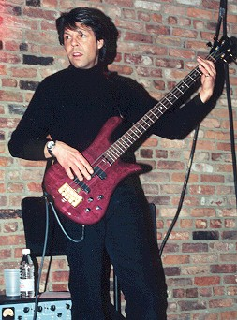
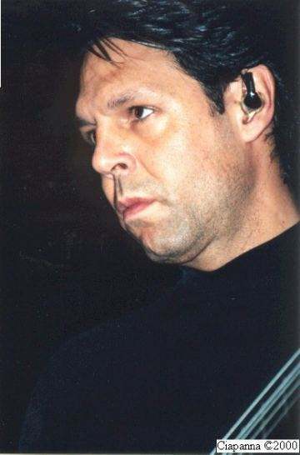 | 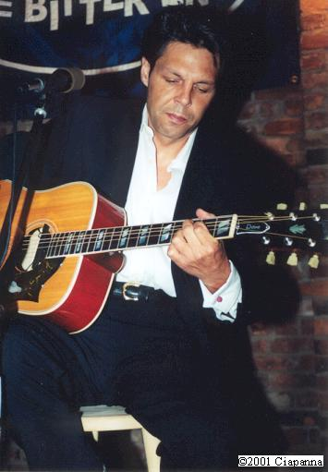
 | 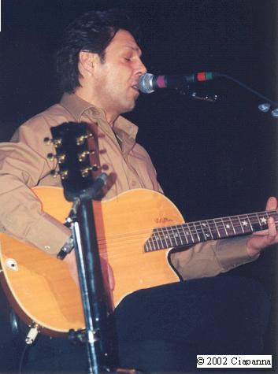
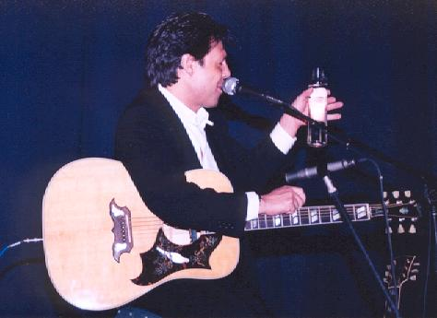 | 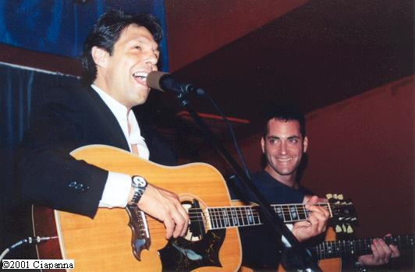

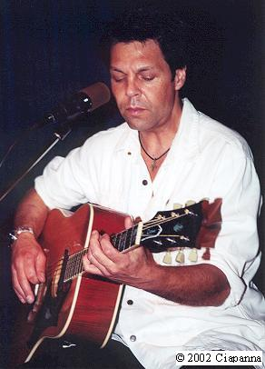

Sometimes controversial, sometimes amusing, sometimes sycophantic, sometimes critical but always a topic of conversation......this is the (subjective) series of essays about Kasim Sulton.

The Kasim Sulton Essay
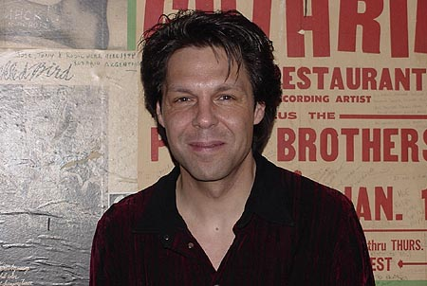

The heading on the top of this page includes the phrase “Sometimes controversial”. As anyone who has browsed the messageboard attached to KasimInfo.com will probably know I’ve used up my controversial quota this week (!) so this essay will probably read more like an article than an essay but it covers one part of Kasim’s career that probably most people do not consider too much.

Kasim Sulton – A Life of Travel

There’s probably not a person reading this magazine that doesn’t know that it was when Kasim Sulton saw The Beatles performing on The Ed Sullivan Show that he decided that he wanted to become a musician. One can only guess what went through this young boy’s mind as he made his life-changing decision but I would bet that it was about making music, playing in front of adoring fans and a life of wealth and riches with first class hotels and travel.

It’s highly likely that young Kasim didn’t think about the downside of being away from home for months at a time and all the non-first class travel and hotels, or the hours in buses or hanging around at airports.

As anybody who has looked at Kasim’s list of touring credits will know, over the years Kasim has toured for a large part of each and every year with all the absences from home that this entails. Only recently when I interviewed Kasim he made the comment “I really didn’t tour much last year - I think I did about four and a half months out of the year with Meat so I had a full seven and a half months at home which for me is an anomaly”. Being at home for over half a year is an anomaly?!!

As the title indicates this essay is focusing on the amount of travel that Kasim has done throughout his career. Hopefully I won’t worry too many people with this next statement but a friend who is a television news show producer has often told me that the majority of journalists that are killed whilst working abroad are not in combat zones but die due to transportation accidents. Think of all the famous musicians who have died in such accidents – Buddy Holly, The Big Bopper, Ritchie Valens, Glen Miller, Marc Bolan, Eddie Cochran, Patsy Cline, Jim Croce, Cosy Powell, Lisa Lopes, plus Ronnie Van Zant, Steven Gaines and Cassie Gaines (all from Lynyrd Skynyrd).

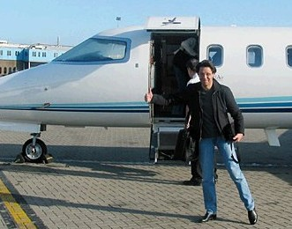

Nowadays, when Kasim tours with Meat Loaf it is (virtually) all first class travel and five star hotels. However it hasn’t always been that way as even in recent years on the Todd Rundgren tours they were flying coach and not always staying at the best hotels. Kasim often tells the story of further back in his career when he was preparing with the rest of the band to travel by van from New York across to Los Angeles for some gigs with Joan Jett but thankfully got the call for some better work which saved him from that trek!

A life of luxury on the road?

Absences from his home and family aside, is the life he leads on the road with Meat Loaf one of total luxury with all pluses and no minuses?

The answer has to be no! Of course there are great advantages to his lifestyle but there are also hours of boredom sitting around in hotels, sitting on the tour bus, hanging around at airports, having to be at reception by a certain time to move to the next hotel and ensuring that you’re not late or you’ll hold up the whole tour party, running the risk of being in a hotel that is located miles from anywhere so you have the choice of expensive room service, a stuffy restaurant or going hungry, visiting various cities but not being able to see them unless you use taxis, checking out of a hotel one morning, driving straight to a venue, playing a concert and then onto your hotel after the show and then having to unpack, living out of a suitcase for months on end, having some TV channels at some hotels and not at others and that’s without concert cancellations or inclement weather delaying flights or whole journeys!

There are also the logistics of what do you take with you? Most seasoned travellers usually get into the habit of just packing the night before or even the morning of the day that they leave. Also often the more seasoned the traveller, the lighter they travel but often Kasim will be travelling to different climates so he may need to take different layers of clothes depending on where they’re expected to travel (and remember that life on the road with Meat Loaf often changes). Plus he gets to know hotel laundries quite well!

There’s also problems like the various currencies required and sometimes the electrical goods. In US the electricity is 110 but in most of the rest of the World it is either 220 or 240. Besides requiring a different plug socket (2 pin in mainland Europe and 3 pin in UK) you must have a converter (like on laptops) to convert the power or goods will catch light! Another alternative is to have a totally different set of electrical goods for the two continents.

What’s the best mode of transport for Kasim?

So far this year we know he’s been on numerous planes, tour buses, cars, trains, an open top red London bus, the back of a horse, an underground train (with me!) and he’s well known for walking to venues that are close by!



Most of Kasim’s travel recently will have been either on the tour bus or by plane. Luckily for Kasim, he is one of these people who can sleep virtually anywhere so a lot of his travel will have been spent catching up on sleep. However (as you’ll see below) there have been some long journeys on the road which are very tedious.

Flying may not be much better. Nowadays with all the added security, a relatively short flight can entail having to get to the airport several hours earlier. At some big International airports it’s easy to kill a hour or two as they contain shopping malls but other airports are far more limited.

How much travelling does Kasim do?

Let’s look at this year - 224 days into the year and where has Kasim travelled? First we must remember that band rehearsals have taken up more of this year than is usual, plus there were a couple of months when he didn’t have much work.

Kasim started 2003 on stage with Meat Loaf in Boca Raton, Florida. They then played the last two concerts of the Winter tour in Orlando and Fort Myers before Kasim returned to New York.

At the end of January Kasim flew to Germany for about a week of promotional work with Meat Loaf. However even during this week, he didn’t just stay in one place as they travelled to different cities by both rail and road.

After returning to New York, Kasim next flew to Atlanta, Georgia for the NBA weekend before another flight back to New York.

His next few public appearances were relatively local for the globe-trotter as he played a gig on Long Island with Meat Loaf and then gigs in Morristown, NJ and Springfield, VA (still a fair drive from Staten Island) with Pat Travers.

The beginning of April saw Kasim returning to Europe (on very short notice) for a stay that he expected to only be for about a week but which in fact lasted almost a month. During this time he visited Germany, Ireland, England, Sweden, England, Holland and then back to England again!

The tour rehearsals started in earnest after he returned to New York. Despite the fact that Kasim wasn’t packing a suitcase he still had a daily commute to the studio each day so he clocked up even more miles!

The rehearsals were interrupted for a short trip across America to Las Vegas before another return to New York. As the first 4 concerts of the tour were cancelled, Kasim was spared another flight across America to the West Coast but he did fly to England in early July. For most of this trip he was located in London but he flew to Belfast and back one day and then travelled down to Plymouth (a 4 hour drive) for one concert before flying back to London for Party In The Park. Kasim then returned to America for the first leg of the US part of the tour.

From 9th July until 2nd August Kasim played concerts in Lansing, MI, Seymour, WI (435), Saint Louis, MO (477), Atlanta, GA (552), Robinsonville, MS (397), Monticello, IA (660), Prior Lake, MN (288), Denver, CO (931), Universal City, CA (1021), Las Vegas, NV (275), Phoenix, AZ (286), Reno, NV (887) and Kelseyville, CA (245). The numbers in parenthesis indicate the miles between each city and total 6,454 miles in 35 days! Plus it doesn’t include that additional travel between the hotels and the venues. Although some were obviously travelled by road, others were flown (with all the subsequent hassle previously discussed).

The next two concerts were cancelled and then Kasim played two shows in Mexico City before another return to New York! The second leg of the tour starts on 23rd August with one months worth of concerts based around the East Coast and the Midwest. After that Kasim posted a couple of days ago that he’s not sure yet whether he’ll be flying to Australia or up to Canada.

The European leg of the tour starts on 25th October in Germany. Contrary to popular belief in America, Germany is a large country so, although the majority of the concerts are in the old West Germany, they will still be travelling quite extensively. Even when they travel to UK, the tour scheduling is not organised too well so there will be a fair amount of driving between the venues from the north of the country to the south and back to the north again, plus two flights to Ireland and back.

The rumors are that this tour will continue until fall 2004 so it seems as though Kasim will be stacking up those frequent flyer miles for quite a while yet to come!

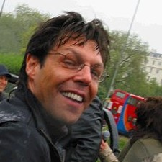

(Please note that the author of this article is purely a fan of Kasim and just an accountant and is no way associated with the music business.)
All The Right Reasons

(Or at least all the right answers to the quiz on page 6)

- Shadoe Stevens
- Anaheim, California
- April 16th 1976
- Jumpin’ Jack Flash
- 49. (The Van Dyke shows were counted separately because tickets were needed for both shows.)
- #27 on March 29th, 1980.
- June and July of 1986
- Scotch and Water

Btw, how well do you know Kasim’s 4 albums? Can you list all the tracks off the top of your head …..in order?

“I've been thinking it over
With no means to an end
Nobody's winning but still you pretend
To have all the right reasons
At all the wrong times
Before we get through saying goodbye
Add up the answers to the sum of why
We had all the right reasons to try”
All The Right Reasons – Kasim Sulton

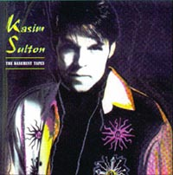

Over For Now…..

That’s all folks! Another edition of the Kasim Sulton Magazine compiled, printed and read! If you have any comments about the magazine, suggestions about how it can be improved, any reviews or photos to submit for future editions or just comments about it in general, please e-mail SueW@KasimInfo.com.

The next edition will be uploaded to the Kasim Sulton mailing list at Yahoo on Tuesday 26th August. The first edition for September will be issued 5 days early on 4th September as it will be a Quid Pro Quo First Anniversary special!

I’m not giving up with this! I STILL Need your help!
For a future feature on both KasimInfo.com and in this magazine, I am looking for anyone who has worked with Kasim Sulton. Whether it was as part of a band, in a recording session or just at venues where he has performed, please could you contact SueW@KasimInfo.com.

